
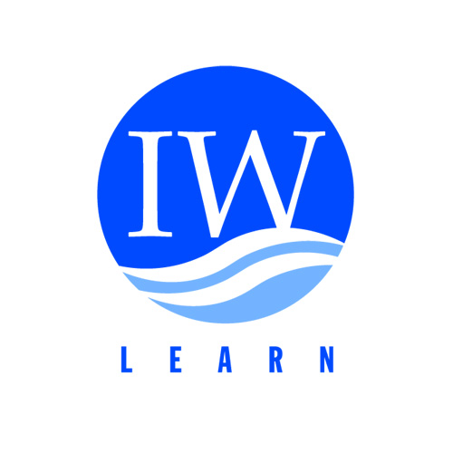
INTERNATIONAL WATERS EXPERIENCE NOTES

http://www.iwlearn.net/experience
Guidance on the Production of
GEF IW Experience Notes
WHAT IS A GEF IW EXPERIENCE NOTE?

An Experience Note is a three-to-six page case study of a given project experience or innovation. Experiences include successful practices, approaches, strategies, lessons, and methodologies, that emerge in the context of Ridge to Reef implementation. It includes a brief project description, the issue faced, a description of how it was addressed (including challenges faced), the results of the intervention, how the intervention can be replicated by other projects and finally what is significant about it. References to related materials are also included. A catalogue of R2R Experience Notes will be made available at the Programme website www.pacific-r2r.org

OBJECTIVE

Experience Notes are intended to facilitate the community of GEF Pacific R2R projects and partners improve R2R implementation through the replication of its own practical experiences & results.

JUSTIFICATION

The importance of Experience Notes lies in the fact that they offer greater detail and reference to given project activities than the average conference presentation and are simultaneously shorter & more accessible than more technical documents (evaluations, implementation reports, et.al.). The Experience Notes offer a solution, being in a sense, the "written version" of a presentation.

SUBJECT AREAS

Subject areas include: Process, Participation, Performance, M&E Process Indicators, M&E Stress Reduction Indicators and M&E Environmental Status Indicators.

Process
- Development and tracking of indicators
- Knowledge management database and IT
- Financing mechanisms
- Public/private partnerships

Participation
- National/regional/local participation
- Leveraging of local funds (public and private)
- NGO participation
- Workshops, training and education programs
- Public relations/outreach/visibility

Performance
- TDA/SAP approval
- NAP development and approval
- Regulatory development and enforcement
- Engineering/investment project completion
- Measurable environmental improvement
- Public private partnerships & market based mechanisms
- Applied scientific research
- Water quality monitoring program implementation
- Species, habitat and ecosystem protection/rehabilitation
- Sustainability issues (post-GEF investment)

Technical
- Wetland restoration practices
- Optimization of wetlands as nutrient sinks
- Primary and secondary wastewater treatment
- Tertiary wastewater treatment
- Cleaner industrial production
- Nutrient management in Agricultural practices

M&E Process Indicators
- Establishment of country-specific inter-ministerial committees
- Completion of a country endorsed TDA
- Documentation of stakeholder involvement in stakeholder involvement plan
- Completion of a country-endorsed SAP
- High-level political commitment to follow up joint actions
- Adoption of a science advisory panel
- Adoption of an M&E plan

M&E Stress Reduction Indicators
- Point source pollution reduction
- Non-point source pollution programs implemented
- Coastal zone or wetlands placed into protection
- Reduced releases of pollution to groundwater recharge zones

M&E Environmental Status Indicators
- Improved (measurable) ecological or biological indices
- Improved (measurable) chemical, physical (including flow regimes), or biological parameters
- Demonstrable reduction of persistent organic pollutants (POPs) in the food chain

Other Areas
- Pollution and water use tariffs
- Economic instruments for water resources management (taxes, tradeable permits, etc.)
- Economic valuation of water-related environmental assets
- Sustainable fisheries management
- Structuring and operation of transboundary waters institutions

PROCESS

Projects and partners should prepare an experience note for submission using the template and guidance as outlined in the following pages. The draft note should be sent to fonongam@spc.int for publication. After an initial review and conversion to the publication template, the note will be reviewed and subsequently posted to the Programme website (the note will also occasionally be disseminated in print form at key events).

INTERNATIONAL WATERS EXPERIENCE NOTES

YYYY-XX

[[Title indicating issue addressed and region - Maximum two lines]]

A striking, but relevant photograph capturing the experience described in the note

Abstract: A short abstract which captures the seminal point from each section (i.e. one sentence each on the project, the issue, how it’s addressed, two sentences on results, replication and significance…space permitting)

[[Author or Editor(s)
[[author/editor(s) email contact]]
[[Project or Institutional Affiliation]]

[[Copy Title from Previous Page]]

Experience of the GEF - sponsored

GEF/[[GEF Agency]]: [[Official Project Title]]
GEFID: XX, [[GEF Agency Project ID]]: XXX

PROJECT DESCRIPTION

Briefly summarize the project’s objectives, expected outcomes and timeframe (from the project document or elsewhere).

In a second paragraph, pertains to a specific project activity, please describe that activity as well.

THE EXPERIENCE

Issue

Provide a short paragraph describing the resource management issue[s] this project addressed. For example, the X stress is affecting X ecosystem in the following way, with the following consequence. The project proposed to mitigate the problem by…X.

Addressing the Issue

Provide multiple paragraphs on the specific actions undertaken by the project to address the issue. These might be sequential or simultaneous interventions.

RESULTS AND LEARNING

Summarize the impacts of this experience on the issues, the project and its partners. What was learned from this experience? Moreover, please attempt to include technical information and references to your project’s indicators where possible. For example, as a result of the X intervention, discharge of X into X was reduced by X%. The outcome of this activity is that the affected-population will realize X benefits. This intervention demonstrates that given an investment of $X can leverage $X of cost-savings.

REPLICATION

What implementation challenges should others expect to encounter when replicating this experience? Highlight specific conditions needed for others to replicate or benefit from this experience. For example, the strategy pursued in this case only works given the following (climatic, socioeconomic, political) conditions…

SIGNIFICANCE

Why is this experience significant to R2R projects and to transboundary water resources management? For example, this experience represents the first time an R2R project has done X.

REFERENCES

How can someone interested in using or adapting this experience get more information? Please provide relevant website(s), documentation and contact information. If you have further materials otherwise unavailable, we are happy to post them to the website as well.

KEYWORDS

What 2-5 keywords could be used to help others search and find this experience note? Please provide at least one of each of the following:

- Forest
- Water basin
- Monitoring

The Global Environment Facility (GEF) International Waters Experience Notes series helps the transboundary water management (TWM) community share its practical experiences to promote better TWM. Experiences include successful practices, approaches, strategies, lessons, methodologies, etc., that emerge in the context of TWM.

To obtain current IW Experience Notes or to contribute your own, please visit http://www.iwlearn.net/experience or email info@iwlearn.net.

