Rehabilitation Maps

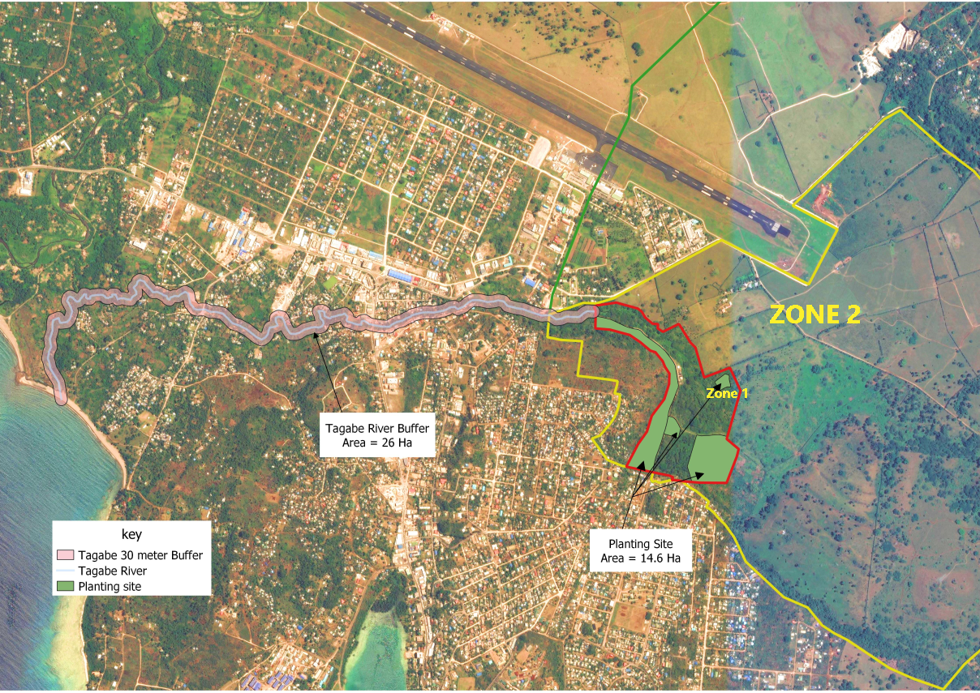
Figure 1 Proposed Rehabilitation Sites for IW R2R Project Vanuatu. This includes rehabilitating the catchment i.e. Water Protection Zones and the buffer areas of Tagabe River.

Figure 2 the current project rehabilitated sites within the Matnakara Water Protection Zone 1. 1.3 hectors of land was restored with 460 native plants from various flora species. The purpose of rehabilitation is to also restore a native forest that should contribute to the overall water resource management in terms of quantity and quality.

Figure 3 Current rehabilitated Sites at the Blacksand Coasal Area towards restoring a native coastal forest with native species to combat impact of CC and coastal erosion. A total of 600 plants from various coastal species were transplanted to the site. Approximately a total 2400m² of area was reforested with native coastal flora species.

