In 1987, the Pohnpei State Legislature passed the Pohnpei Watershed Forest Reserve and Mangrove Protection Act, setting aside roughly 5000 hectares of upland forest as a protected Watershed Forest Reserve. The main purpose of the act was to halt poor land management practices such as the rampant deforestation for sakau farming and other activities in order to protect ecologically important areas of the watershed and water supply for the island among others.
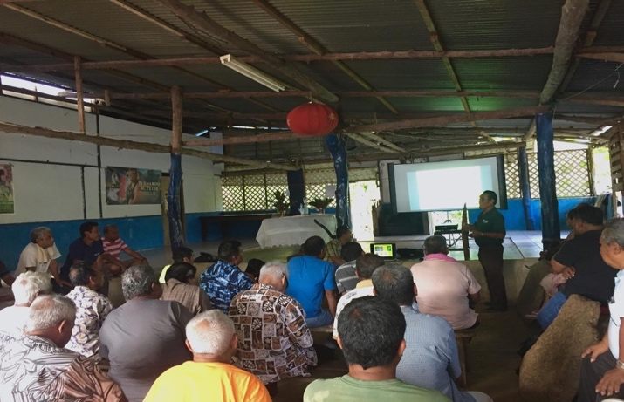
Many stories are associated with the implementation of this Act in Pohnpei, such as locals chasing surveyors with machetes and guns in the uplands to government officials being reluctant to support the work with fear of backlash among voters and so forth.
Fast forward to 2017, the delineation of the Watershed Forest Reserve remains not only incomplete but became arguably the biggest challenge for natural resource managers in Pohnpei State.
The Ridge to Reef Project is committed to taking this challenge head on. The many unsuccessful attempts to complete the line in the past will serve as lessons-learned as the Ridge to Reef Project continue to revive this effort. An important note is that only Kitti and Nett Municipalities have yet to be delineated.
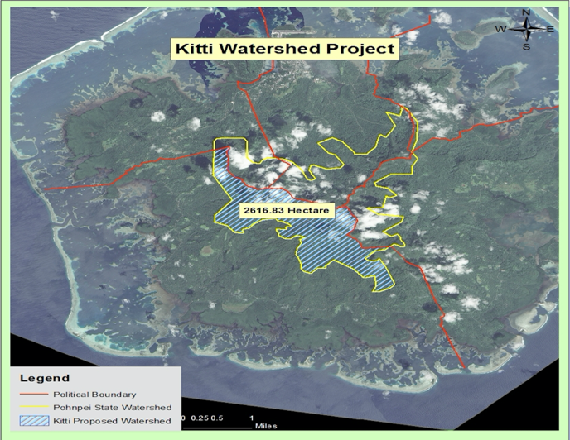
Spearheaded by the Pohnpei R2R State Coordinator and through the assistance of partner agencies, the Ridge to Reef Project successfully obtained the blessing and support of one of the most important group in Pohnpei, the Council of Kitti Traditional Leaders (Pwihn en Wahu en Wein Kitti), to move forward in completing the delineation of the Kitti Watershed Forest. This endorsement by the Traditional Leaders was brokered through a series of meetings and consultations held throughout month of May 2017. Stakeholders for the Ridge to Reef Project are currently finalizing field work plans. Delineation of the Kitti Watershed is scheduled to begin in mid-June to August, 2017.
More updates on Watershed efforts will be provided later as field work begins.
For more details on the R2R project in the FSM, please contact:
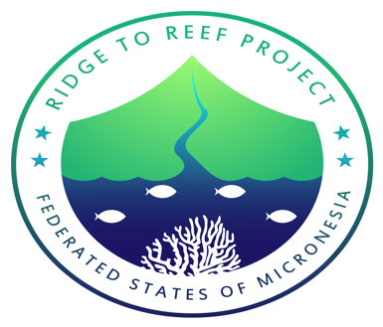
National Project Implementation Unit: Project Manager, Rosalinda Yatilman, ryatilman@gmail.com

Chuuk State R2R Coordinator: Kriskitina Kanemoto, krizk66@gmail.com

Kosrae State R2R Coordinator: Blair Charley, charleyblair@gmail.com

Pohnpei State R2R Coordinator: Jorg Anson, jorgyanson@gmail.com

Yap State R2R Coordinator: Debra Laan, debra.laan@gmail.com

