Press Release
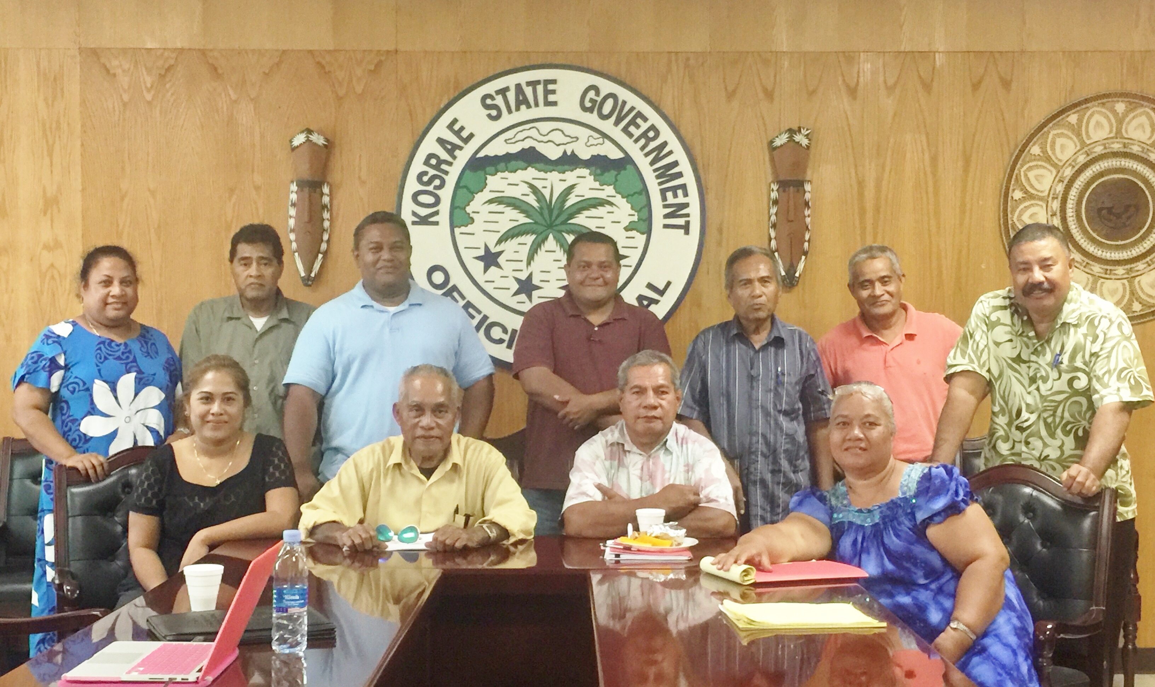

TOFOL, Kosrae – On February 6, 2017, the Kosrae Ridge to Reef (R2R) Technical Advisory Committee (TAC), in collaboration with the R2R National Project Implementation Unit (PIU), held its second TAC meeting at the Governor’s Conference Room to review and discuss Kosrae's recently endorsed R2R 2017 Annual Work Plan (AWP). Participants included government agencies, NGOs and key community leaders involved in conservation.

To facilitate R2R implementation at the State-level, a TAC is established in each state to provide a local communication and discussion platform comprising all implementing partners and other key stakeholders involved in the project implementation. Formed by the state focal point, the Kosrae Island Resource Management Authority (KIRMA), the TAC is chaired by the Chairman of the Environment, Transportation, Communications and Infrastructure Committee of the 11th Kosrae State Legislature, Senator Salpasr Tilfas and Co-Chaired by the Mayor of Malem Municipality, Mr. Grant Jonas. Members include KIRMA, Department of Resources & Economic Affairs, Department of Health Services, Department of Education, Kosrae State Legislature, the four Municipal Mayors, Kosrae Senior Citizens Association, Kosrae Women Association, Kosrae Youth Development Association and the Kosrae Conservation & Safety Organization.

The meeting, called by the Chairman, was attended by several TAC members and staff of the National PIU, the R2R Project Manager, Ms. Rosalinda Yatilman and the Financial Administrator, Ms. Alice B. Ehmes. A presentation of the project was delivered by the Project Manager, highlighting the background, goal, objective, the project's two main outcomes and its expected deliverables across all the FSM States. This provided the opportunity for participants to raise questions and concerns relevant to the project and its recently endorsed work plan, and for the National PIU to address them.

Updates were also provided on technical issues delaying the project's first quarter financing from UNDP's Regional Office in Fiji. Other concerns pertaining to the roles of each respective TAC in relation to the National TAC were also discussed, followed by the review of Kosrae's TAC Terms of Reference.

The meeting concluded with a closing remark by the co-chair, noting and appreciating the presence of the Project Manager and the Financial Administrator and everyone for their time in attending the meeting.

Stay tuned for our next R2R update!

For more details on the R2R in FSM project, please contact:

National Project Implementation Unit: Project Manager, Rosalinda Yatilman
ryatilman@gmail.com
Tel:+691 320-8815
Fax: +691 320-8936

Chuuk State R2R Coordinator: Kriskitina Kanemoto, krizk66@gmail.com

Kosrae State R2R Coordinator: Blair Charley, charleyblair@gmail.com

Pohnpei State R2R Coordinator: Jorg Anson, jorgyanson@gmail.com

Yap State R2R Coordinator: Debra Laan, debra.laan@gmail.com

