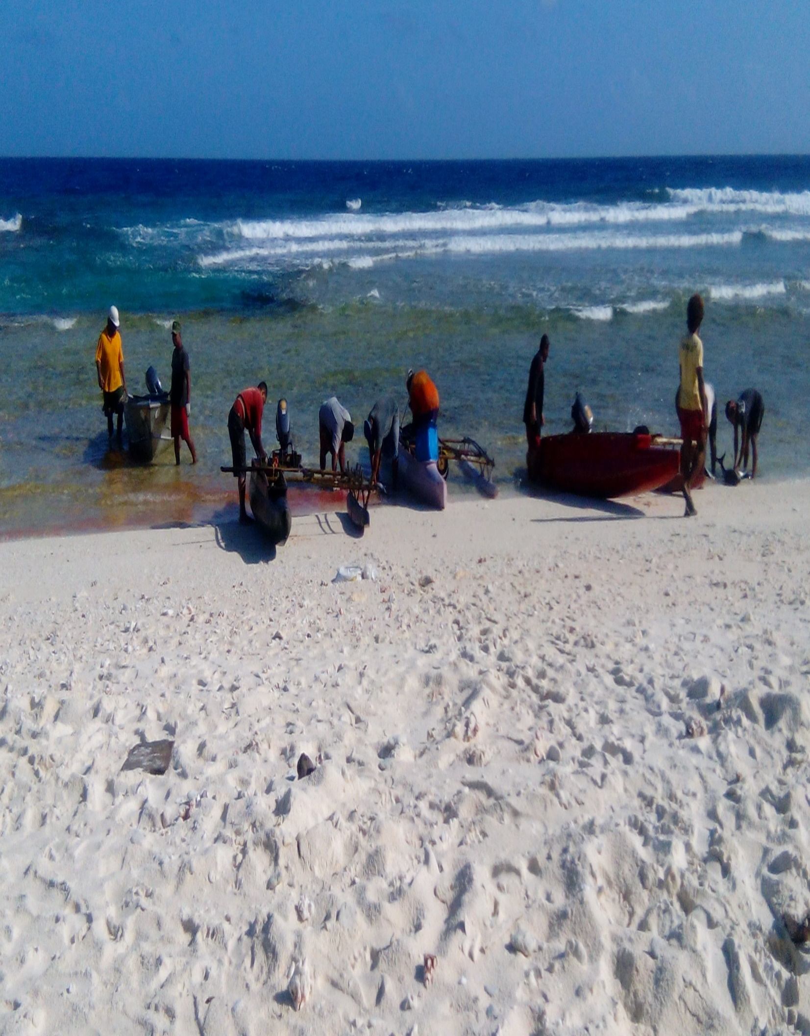
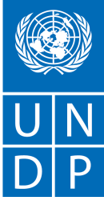
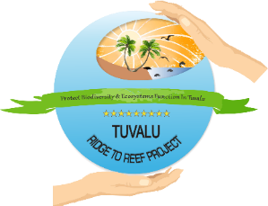
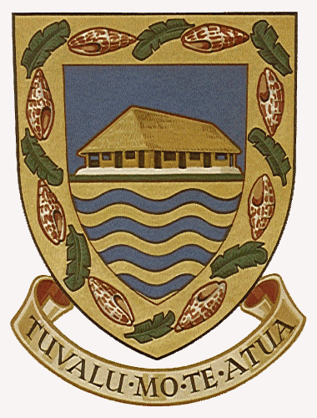

Locally-Managed Marine Areas in Tuvalu:
A training manual for Island Communities and conservation partners

Prepared by Feagaiga Penivao
3 April 2018
Tuvalu Ridge to Reef Project
Acknowledgements
The development of this manual was only possible and successful through the collective contributions and efforts from various institutions and communities. In particular, the Tuvalu Ridge to Reef Project wishes to thank the Tuvalu Coastal Fisheries Section of the Department of Fisheries for their technical support and involvement in developing this manual. Special thanks go to Fiji Locally Managed Marine Areas Network (FLMMA) for providing information to assist in formulating this manual, and also training R2R Team and other key stakeholders on how to conduct community based adaptive management and monitoring plan for Tuvalu.
The R2R project also expresses its gratitude to Funafuti Community for their great support and participation in the practical exercise of FLMMA Training on community based adaptive management for Funafuti. Acquiring skills and knowledge by R2R Team on community based adaptive management, optimizing the Team to have confident in extending this work to outer-islands to develop their management plan and monitoring Plan with assistance from Island Kaupule.

Contents
1 Introduction 1
1.1 LMMA Approach to coastal protection and management 1
1.2 Purpose of this manual 1
1.3 Who this manual is intended for 1
1.4 What is a Locally – Managed Marine Area? 2
1.5 What is a No-take area? 2
1.5.1 Benefits of No-take Areas 2
1.6 What is Community-Based Adaptive Management (CBAM)? 3
2. The Four Phases to Establish an LMMA 3
2.1 INITIAL ASSESSMENT (Phase 1) 4
2.1.1 Evaluate Community Request 4
2.1.2 Stakeholder Assessment and Consultation 4
2.1.3 Community Familiarization 4
3. LMMA DESIGN AND PLANNING (Develop Management Plan) (Phase 2) 4
3.1 Management Planning Process Design/Flow 5
3.2 Situation Analysis 5
3.2.1 Mapping 5
3.2.2 Transect Walk 7
3.2.3 Historical Profile/timeline 8
3.2.4 Problem Identification 9
3.3 Learning & Awareness 10
3.3.1 Root Cause Analysis: Problem Tree 11
3.3.2 Stakeholder Analysis: Venn diagram 11
3.3.3 Visioning 12
3.3.4 Seasonal Harvest Calendar (optional) 12
3.3.5 Priority Matrices and Ranking 13
3.4 Action Planning 13
3.4.1 Management Options 14
4. IMPLEMENTATION OF COMMUNITY BASED ADAPTIVE MANAGEMENT (CBAM) (Phase 3) 15
4.1 Letting Other Knows 16
4.1.1 Communication to Stakeholders 16
4.1.2 Determining Stakeholders’ Roles 16
4.2 Biological Monitoring 16
4.2.1 Review Management Plan 16
4.2.2 Selecting Biological Indicators 17
4.2.3 Methods Training 17
4.2.4 Practical Exercise 20
4.2.5 Conducting a Baseline Survey 20
4.2.6 Data Analysis 21
4.2.7 Develop Monitoring Plan 21
4.3 Socioeconomic Monitoring 22
4.3.1 Methods Training 22
4.3.2 Develop Socio-economic Monitoring Plan 22
5. ONGOING COMMUNITY BASED ADAPTIVE MANAGEMENT 23
5.1 Review Action Plan and Monitoring Data 23
5.1.1 Community-Based Adaptive Management Meetings 23
5.2 Maintaining No-Take Area Effectiveness 23
5.2.1 Declaration of Conservation area 24
5.2.2 Demarcation of Conservation Area Boundaries 24
5.2.3 Patrolling 25
5.2.4 Sharing Lessons Learned 25
5.2.5 Upscaling LMMA Work 25
6. References 26

List of Figures
Figure 1: Above is a diagram for the four phases to establish LMMA 3
Figure 2: Funafuti Community 6
Figure 3:Nanumaga Community 7
Figure 4: Funafuti Youth conduct a Transect walk 8
Figure 5: Nanumea Community 9
Figure 6: Nukufetau Community 10
Figure 7: A general example of a Problem Tree from Funafuti Workshop 11
Figure 8: R2R Island Officers present Stakeholders Analysis during FLMMA training workshop 12
Figure 9: Sample of Funafuti Vision from Funafuti ISP 12
Figure 10: Presenting Management Plan at a community meeting, Funafuti 16
Figure 11: Ridge to Reef diver conducting belt transect, Funafuti. 17
Figure 12: Ridge to Reef diver conducting line transect with quadrat, Funafuti. 18
Figure 13: Fisheries Officer conducting Creel Survey in Nui Island 19
Figure 14: Ridge to Reef Team practicing transect method, Funafuti. 20
Figure 15: Conservation Area Map provided by the Ridge to Reef Project and Tuvalu Fisheries Department. 24
Figure 16: Funafuti Conservation Officer and Ridge to Reef Team patrol Funafuti Conservation Area.. 25

List of Tables
Table 1: Steps and tools used during a participatory planning workshop 5
Table 2: Historical Timeline. The above is a sample table for filling in historical data 8
Table 3: A sample table of Pair-Wise Ranking from FLMMA training workshop in Funafuti. 13
Table 4: Example of a completed action planning matrix, based on the Marine Resource Management Plan for Korolevu-i-wai, Fiji November 5-7, 2002. 14
Table 5: Data Analysis of Waitabu MPA, Fiji. 21
Table 6: Above is an example of a biological monitoring plan from a Fiji LMMA site 21
Table 7: Above is an example of a socio-economic monitoring plan for the Vueti Navakavu Project in Fij 23

1 Introduction

1.1 LMMA Approach to coastal protection and management
Coastal fisheries resources have sustained Pacific peoples for thousands of years. Today, coastal fisheries contribute significantly to the food security, livelihood and culture of both rural communities and urban populations throughout the Pacific. Many years ago traditional management system was proven to be successful and effectively achieved by communities in managing local marine resources. Recently, modern approaches and management systems were introduced to Pacific island communities for the purpose of enhancing and sustaining coastal fisheries management. Unfortunately, it is generally recognized that modern interventions or top-down coastal protection and management approaches do not meet the needs of the Southeast Asian and Pacific Islands communities. Therefore integration of co-management of coastal fisheries between national institutions and communities leads to worthwhile decision making on improving locally managed marine areas.

1.2 Purpose of this manual
This manual is intended to help coastal communities and their conservation partners to develop, design and implement LMMA interventions into their adaptive management systems. By following this manual, communities may have the potentials and knowledge to equally manage their marine resources using traditional practices. The tools provided in this manual help to understand the process in developing LMMAs and other management mechanisms that are suitable for Tuvalu’s context.

1.3 Who this manual is intended for
This manual is intended for coastal community members, island leaders, Kaupule members, as well as partner organizations that support them and their local management efforts. Partners can include government agencies, non-government organizations and other interested parties who involved in coastal fisheries management.

It is expected that the reader is a community members or leaders who will be leading the LMMA approach. It is also assumed that the reader has some basic knowledge about the local site, the people who live there, and the coastal resources that are found there and are being used locally.

1.4 What is a Locally – Managed Marine Area?
This manual follows the definition of a locally-managed marine area (LMMA) as:
“An area of nearshore waters and coastal resources that is largely or wholly managed at a local level by the coastal communities, land-owning groups, partner organizations, and/or collaborative government representatives who reside or are based in the immediate area.”

Establishment of an LMMA enables communities to make decisions on which fishing methods and other activities can or cannot be carried out in their waters. Typically, a community also designates a portion of their marine area as a no-take zone where no fishing is allowed, providing additional protection and an increase of marine life in many cases.
Top Reasons for Using an LMMA Approach
- Improved habitat quality (coral cover, seagrass, mangroves)
- Increased fish population, reproduction and biomass
- Enhanced local capacity to manage their resources
- Increased environmental stewardship and community cohesion
- Increased income from marine resources

1.5 What is a No-take area?
A no-take zone also known as a marine reserve, marine protected area is a coastal or marine area that is closed off to all fishing, either temporarily or permanently. After studying how to manage coral reef fisheries resources for many years, fisheries scientists have discovered that the best way to manage coral reef resources is to establish permanent no-fishing areas.

1.5.1 Benefits of No-take Areas
- No-take areas provide an undisturbed place for fish and other marine life.
- No-take areas allow spillover of fish and other marine life to fishing areas.
- No-take areas allow fish and other marine life to become big enough to reproduce.
- Permanent no-fishing areas help restore critical spawning densities.

All islands of Tuvalu had longed practiced locally-managed marine areas for many years except for Funafuti Islands which legally established a Marine Protected Area (MPA) that bind by the Conservation Area Act. Enforcement of traditional management system and regulation proven to be successful and effective in locally managed marine areas in Tuvalu.

1.6 What is Community-Based Adaptive Management (CBAM)?

Adaptive management can be defined as the integration of design, management and monitoring in order to learn and improve responses to management efforts. It is an ongoing cycle of designing and checking a plan and then modifying management in light of the results. This implies the drawing up and agreement of a management plan, a method of checking/monitoring results, and regular analysis and discussion of whether the plan needs improving.
Community-based implies that the management is carried out by, or with a major role played by the community, local stakeholders, relevant user groups, and also the locally and nationally relevant institutions and private interests.

The Four Phases to Establish an LMMA

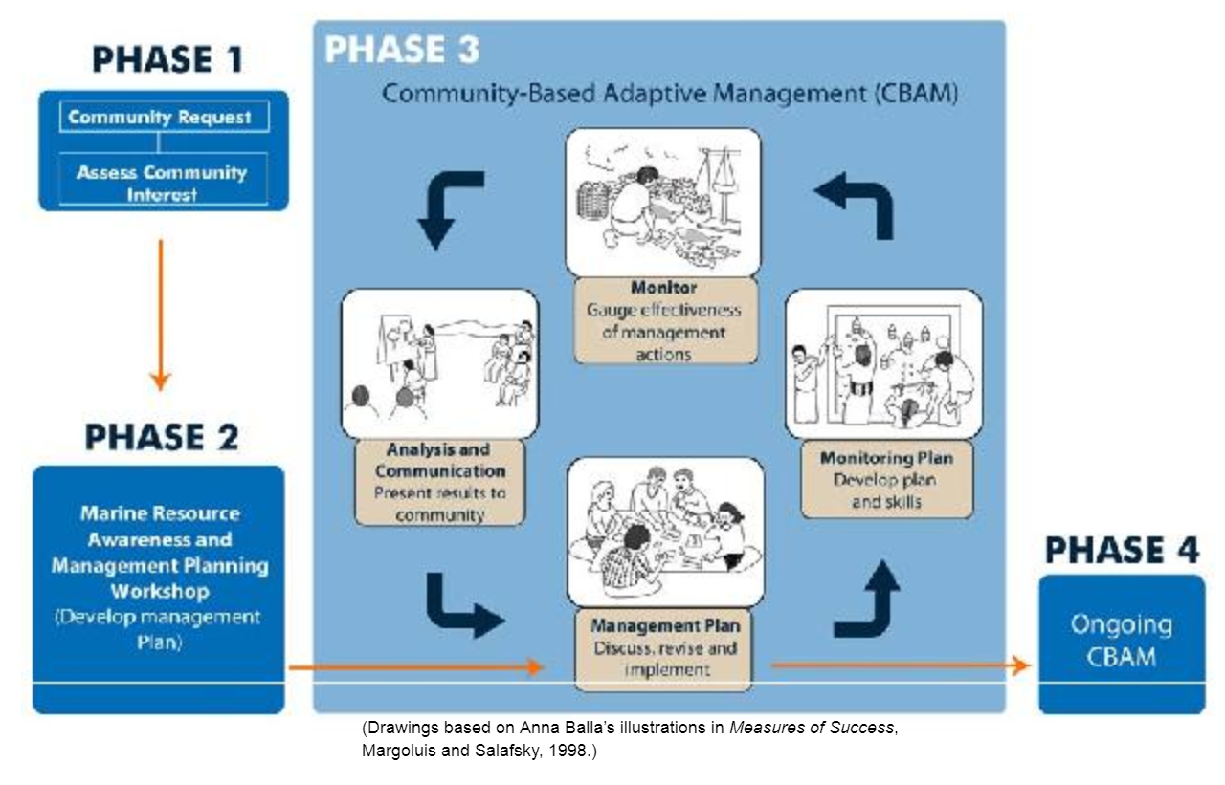
Figure 1: Above is a diagram for the four phases to establish LMMA. Source: (Govan, Aalbersberg and Tawake, 2008)

2.1 INITIAL ASSESSMENT (Phase 1)

2.1.1 Evaluate Community Request
Communities through Island Kaupule communicate their request to the Department of Rural Development (under the Ministry of Home Affairs and Rural Development) to seek technical assistance in establishing their LMMA in their home islands. Upon receiving formal request from Island Kaupule, the Department of Rural Development immediately call a meeting with the Department of Fisheries to discuss and assess the request from Island Communities for the establishment of their LMMA.

2.1.2 Stakeholder Assessment and Consultation
The Department of Fisheries identifies different interest groups and people that may be involved in the project. Initially, a stakeholders meeting must be carried out to discuss potential commitment from various stakeholder to builds a common understanding of the different roles and interests that they may have in setting a foundation for the development of an LMMA. The Department of Fisheries leads the discussion to highlight various mandatory and commitment from different sectors and develop a Terms of References for the team to follow.

2.1.3 Community Familiarization
Tuvalu Fisheries Department and project partners travel to outer islands and meet with Kaupule and Falekaupule on their request for establishing an LMMA. Communities and project partners discuss the purpose of the request, clarify issues and expectations of the project. Once the initial assessments and consultations are completed, the communities and project partners need to agree on the overall process of the project, the respective costs and expected benefits.

  - 4 Planning for Next Stage
Once the team returned to Funafuti, they will conduct a debriefing to discuss the outcome of their meeting with the community. Once all the needs from the community assessed and finalized, a Terms of References need to develop for the project to highlight facilitators’ role and all the activities, materials and cost incurred within a given timeframe.

LMMA DESIGN AND PLANNING (Develop Management Plan) (Phase 2)

3.1 Management Planning Process Design/Flow
Communities and project partners are involved in the participatory planning process to develop a management plan that helps the community to manage and monitor their marine and terrestrial resources. Through this process the community must agree on the outcome, objectives and procedures of the workshop to identify the problem associated with managing marine resources and how the communities can address this problem using several tools and exercises.

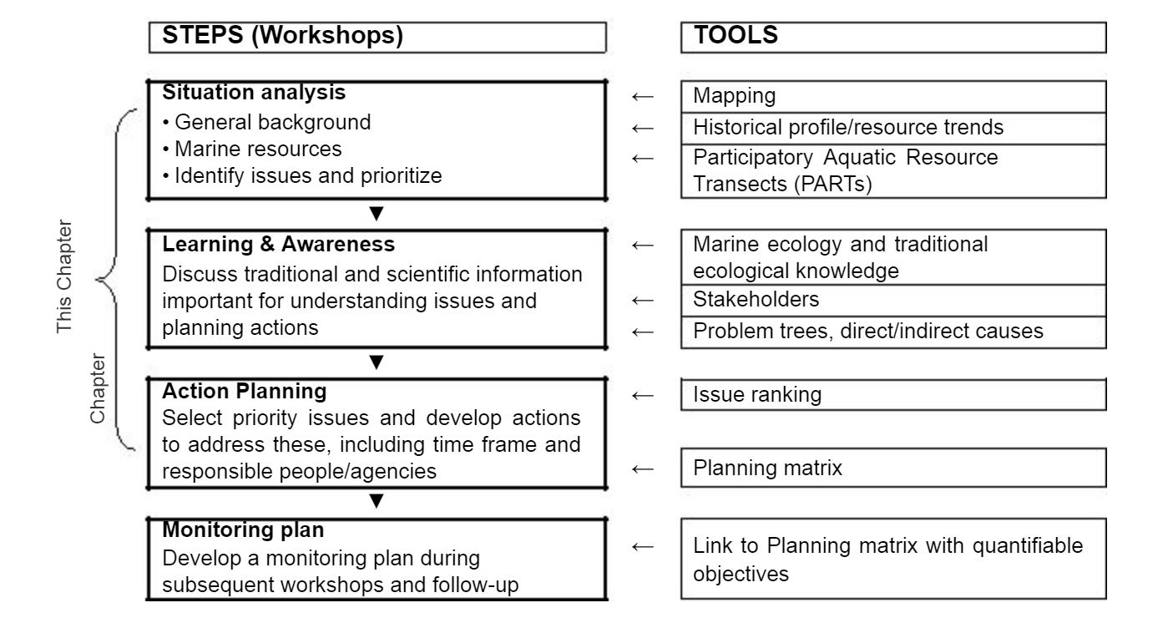
Table 1: Steps and tools used during a participatory planning workshop (Govan, Aalbersberg and Tawake, 2008)

3.2 Situation Analysis
This is a general background of the islands biodiversity, in particular with status of the marine environment that used by the community from many years ago until now. It focuses on mapping important locations for marine species and identifies issues and problems associated with coastal resources. The aim of this exercise is to identify issues that relate to marine resources management and how communities can prioritize those issues that urgently need to be addressed and resolved.

3.2.1 Mapping
A process in which participants are divided into groups to record and discuss a geographic representation of the important features of the land and sea area they want to manage such as coastline, vegetation and forestry, infrastructure, marine resources, etc. Different groups have different ecosystems to map out. For example, the fishermen group only map out the marine resources and important features found within the coastal fisheries. The aim of this mapping exercise is to identify the location of natural resources and community infrastructure and their coverage. The groups can also identify the problem associated with each of the land and sea areas to capture natural and human drive of the problem.

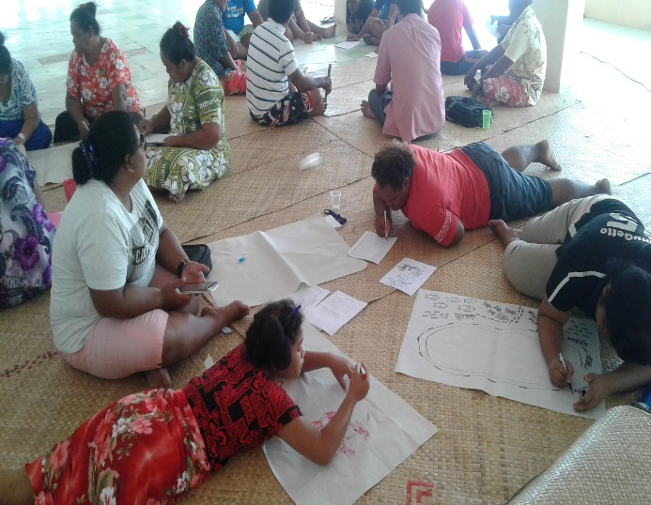
Figure 2: Funafuti Community photo by Feagaiga Penivao (20/02/2017)
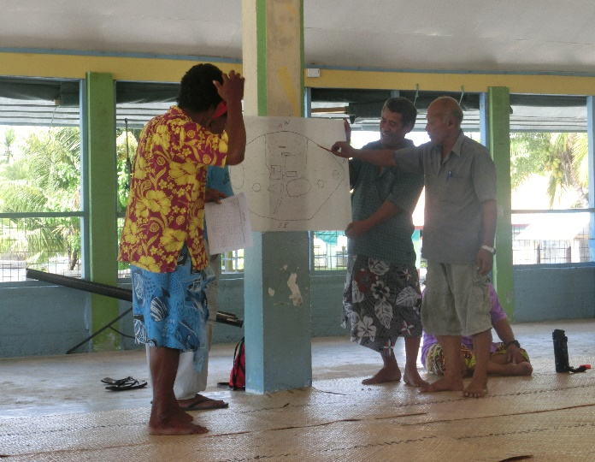
Figure 3:Nanumaga Community photo by Feagaiga Penivao (22/03/2017)

3.2.2 Transect Walk
A descriptive assessment of the uses and status of the local marine habitat types and resources, based on the visual observation of community members walking along a straight line across a specified cross-section of nearshore environment and take note of the status of marine habitats and important resources they found. The aim of the transect walk is to characterize the habitat types and important resource species found within the coastal waters of the area being locally-managed, and identify common marine resource uses, issues and opportunities within the local area.
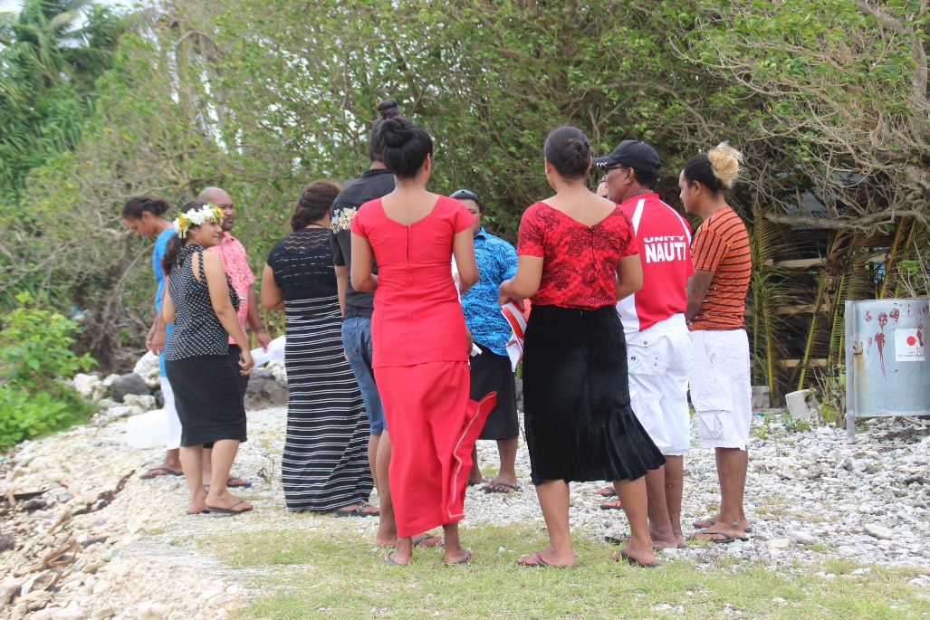
Figure 4: Funafuti Youth conduct a Transect walk photo by Feagaiga Penivao (16/02/2018)

3.2.3 Historical Profile/timeline
This is a list of important events or major decisions that have occurred within the community’s history that helps to identify past issues, problems, and any steps taken or achieved to overcome them. Each groups (community members) will discuss and record important events occurred in the past 40 years until the present. The aim of this historical profile is to identify, discuss, and understand how events and decisions that have occurred at local, national, and international levels relate to or have influenced the community’s use of its coastal resources.

Sample Historical Timeline Table
Factor or event | 1960 - 1980 | 1980 - 2000 | 2000 - Present
Population
Fishing Methods
Major developments
Agriculture
Cyclone/Storm surge
Political events
Table 2: Historical Timeline. The above is a sample table for filling in historical data (Govan, Aalbersberg and Tawake, 2008)

3.2.4 Problem Identification
A process in which the problems and issues affecting the community and its resources are identified and clarified so that they can be addressed later in the planning process. Brainstorming is a useful tool to identify problems by generating a broad list of ideas from group participants. The primary rule is that everyone is encouraged to call out as many ideas as possible. All ideas are valid and the facilitator must encourage everyone to contribute as much as possible until the flow of ideas has stopped.
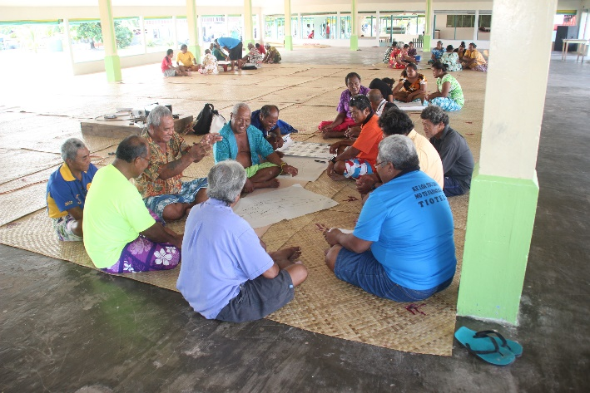
Figure 5: Nanumea Community photo by Feagaiga Penivao (25/04/2017)
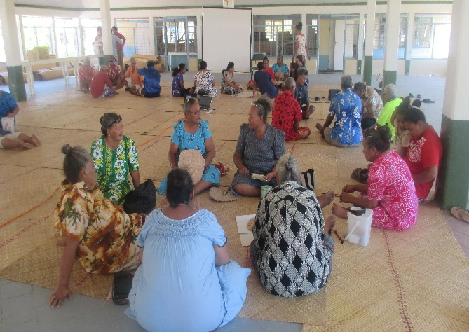
Figure 6: Nukufetau Community, (17/02/2017) photo by Lamese Saamu

3.3 Learning & Awareness
This is a process where community and project partners discussed traditional and scientific information, methodology and tools that most important for understanding various issues and planning actions. It provides an opportunity for communities and project partners to share their experiences and knowledge on defining various issues and actions that needs to be done.

3.3.1 Root Cause Analysis: Problem Tree
This is a method to determine root causes of problems and identify possible solutions. Communities will identify the main problems/issue follow by highlighting the root causes that driven the problem. The idea of this exercise is to help participants identify and agree on the underlying causes of problems and examine the links between these root causes and their effects. Problem tree is a useful tool to identify the root causes of the problem and provide appropriate solutions to address the problem.

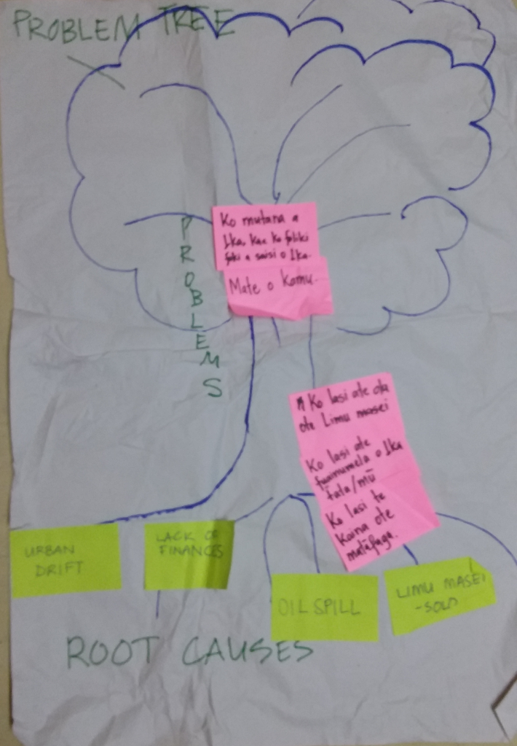
Figure 7: A general example of a Problem Tree from Funafuti Workshop. photo by Feagaiga Penivao (16/02/2018)

3.3.2 Stakeholder Analysis: Venn diagram
The community identifies the major stakeholders that use or have an interest in the target site and related resources, how important they are in terms of use and potential management of the marine resources, and how they relate to each other. Bigger circles indicates the most supportive stakeholders towards the community project, while smaller circles indicates less support to community projects. The aim of this exercise to identify the important stakeholders and how they relate to each other and to the marine resources at the site in order to provide the basis for discussions on who can and should be involved in putting plans into action and where relations can be improved.

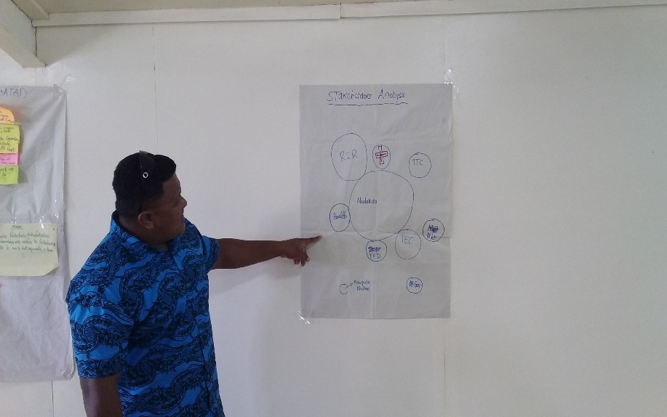
Figure 8: R2R Island Officers present Stakeholders Analysis during FLMMA training workshop. photo by Feagaiga Penivao (13/02/2018)

3.3.3 Visioning
The communities has to decide what their expectations in 10,20,30,50 years’ time on the status of their natural resources, economic development, and traditional or cultural livelihood. The aim of this exercise to brainstorm the community on what their vision for the future based on the need to improve community livelihood thus enabling communities to work accordingly to achieve the vision.
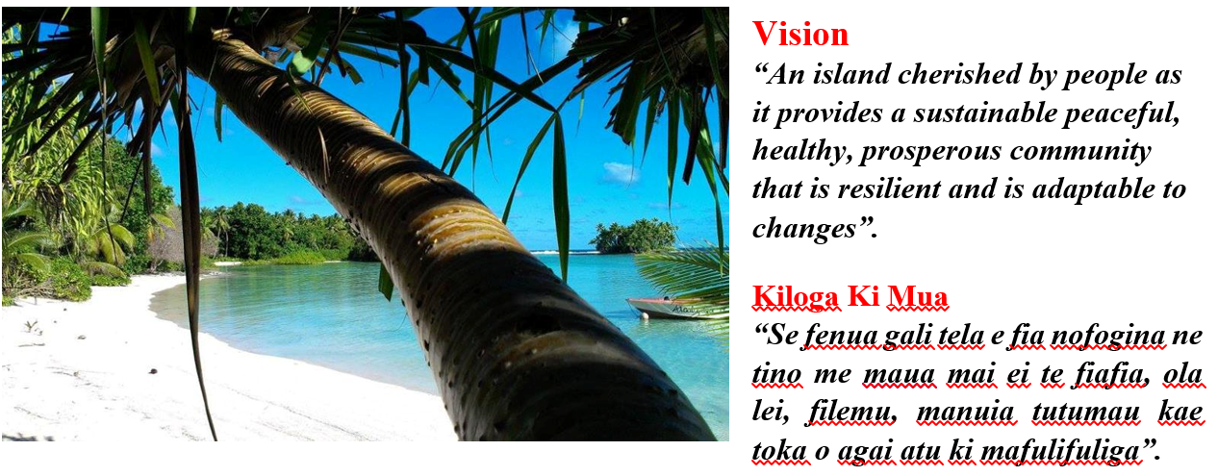
Figure 9: Sample of Funafuti Vision from Funafuti ISP, (MOEAKIGA O MALEFATUGA II, 2016)

3.3.4 Seasonal Harvest Calendar (optional)
This exercise helps communities examine changes that happen to their marine resources over the year. The communities identify various species that seen as abundant or easily to catch over the year, and management activities adopted to control the overharvesting of certain species. For example, certain resources may fluctuate seasonally, and other activities may dominate the community’s time and attention; these will impact potential management activities. The aim of this exercise is to discuss and record the variations in factors affecting the community and its resources over an average year.

3.3.5 Priority Matrices and Ranking
Pair-Wise Ranking is a tools that rank issues/threats according to their priority in the community. Issues/threats are paired and compare their ranking based on urgency and timely cost effective. In each open box, compare the threat/issue listed in the top box against the list on the far left and tally the result. Repeat these paired comparisons until all open boxes have been filled in with the selected threats/issues. The issue/threat have the highest total number, rank as a top priority issue for the community that urgently need to solve, other issue will rank accordingly to their result. This exercise will help the community identify where they should focus their LMMA efforts and time.

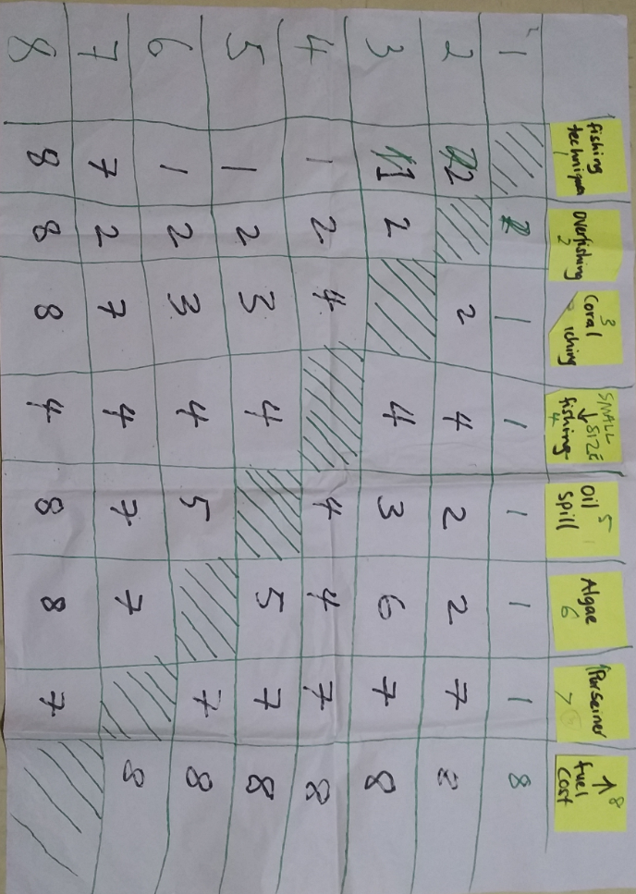
Table 3: A sample table of Pair-Wise Ranking from FLMMA training workshop in Funafuti. Photo by Feagaiga Penivao (16/02/2018)

3.4 Action Planning
This is the key outcome of the process and defines implementation and guides monitoring. During a community workshop, the community lists down priority management actions to be taken, including timing, the problem being addressed, and who will be involved, with regard to the threats/problems identified in earlier exercises. This action plan provides guidance for community’s actions and reference points for monitoring progress of regular activities. It is important that the action planning matrix be as specific and detailed as possible with descriptions of steps to be taken and clear timeliness. It is helpful to publish your plan on posters to increase the awareness and commitment of the community and to inform outsiders of your activities.

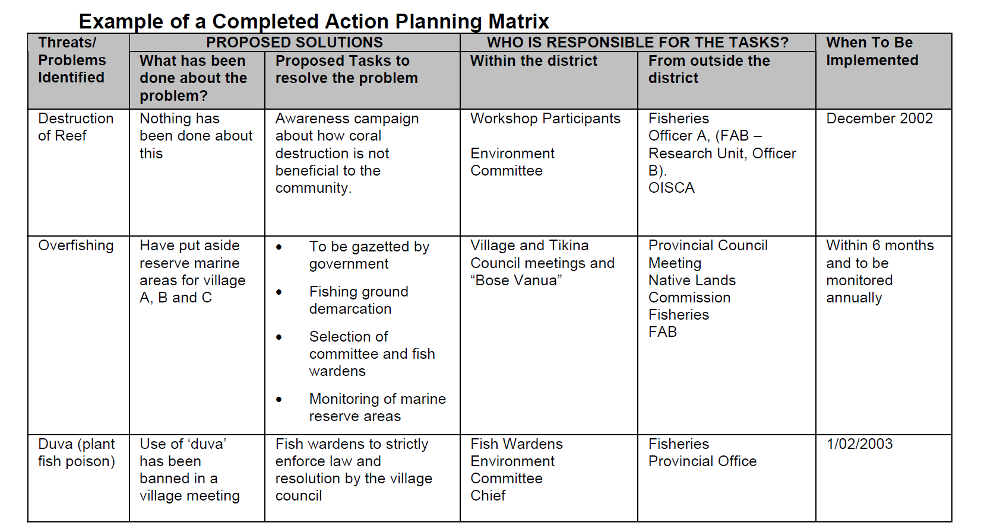
Table 4: Example of a completed action planning matrix, based on the Marine Resource Management Plan for Korolevu-i-wai, Fiji November 5-7, 2002 (Govan, Aalbersberg and Tawake, 2008).

3.4.1 Management Options
When designing the management action plan, communities need to consider their best options; the strategies chosen should address the root causes of fisheries decline identified by communities in previous exercises (for example, if the root cause of decline is thought to be introduction of gill nets in the 1960s, then gill net management should be part of the management plan).
Below is a list of management strategies that may be adopted by communities, depending on their site.

- Permanent no-take zones (marine reserves, marine protected areas, etc).
- Rotational or temporal no-take zone (giving the reef a resting period)
- Zoning the management area – delineating different areas for different uses (for example, banning commercial fishing where it competes with subsistence fishing or tourism, etc.)
- Regulate or ban night fishing with underwater lights
- Regulate or ban spear fishing using SCUBA
- Control the use of pressurized gas or SCUBA for harvesting beche-de-mer (sea cucumbers), etc.
- Ban the harvest of egg-bearing female lobsters or crabs
- Establish size limits for clams, lobsters, crabs, octopus, and certain fish
- Control the use (and sale) of small-mesh fish nets (require a minimum mesh size of 3 inches for most types of net fishing)
- Ban gill netting, or replace gill nets with fish traps that don’t kill the fish, so that rare species can be released. Use fish traps and fish fences to replace some types of net fishing (perhaps using more durable modern materials).
- Protection of spawning aggregations from fishing
- Seasonal closure of a fishery (during reproductive season)
- Ban on harvest of very rare species in the larger management area (turtles, bumphead parrotfish, humphead wrasses, triton’s trumpet or other shells, etc.)
- Discouraging destructive practices such as walking on corals, anchoring on corals (make
- permanent moorings, or buy or make sand anchors), and harvesting corals (replace with
- sustainable coral farming)
- Ban the disposal of rubbish into the sea, especially plastics, batteries, and cans
- Removal of crown of thorns starfish if there are > 5 per hectare
- Removal of tree trunks that wash up or fall onto the reef, as they roll around during storms,
- smashing corals
- Replanting corals to dredged or dynamited reefs that are not recovering
- Planting corals (staghorn types) for fish houses where the corals have died out or where there is a deficiency of fish habitat
- Restocking or aggregation of surviving rare shellfish within a limited area of a no-take zone, with proper monitoring and a protection program
- Training and activation of community “Conservation Officer”
- Limiting the numbers of commercial fishers in a particular area
- Development of effective enforcement and problem-solving process in the community
- Reduce nutrient pollution to reefs by improving sewage systems and reducing other sources of nutrients such as run-off from piggeries, fertilizer, etc.
- Other sorts of sustainable management practices

IMPLEMENTATION OF COMMUNITY BASED ADAPTIVE MANAGEMENT (CBAM) (Phase 3)

4.1 Letting Other Knows

4.1.1 Communication to Stakeholders
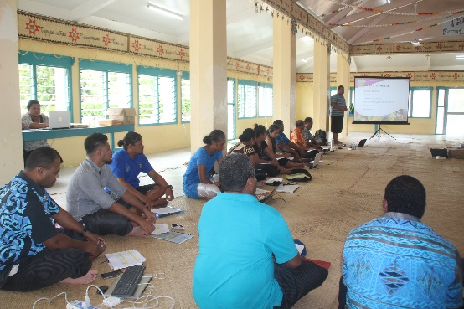
Typically LMMAs are developed by a group of representatives of a community or communities with facilitation by government and/or non-government staff during a workshop. This group needs to then take the action plan that has been developed back to the community (Falekaupule) and others involved with or interested in the project for presentation and discussion. The aim of this exercise is to ensure that all community members and other stakeholders are aware of the action plan and agree with its contents.

Figure 10: Presenting Management Plan at a community meeting, Funafuti. Photo by Josh Tui (20/02/2017)

4.1.2 Determining Stakeholders’ Roles
Action plans usually include an indication of who will be the main implementers of each action and who will assist. The Island Kaupule is the leading implementers for the Action Plan follow by government institutions and NGO’s that assist in the implementation of the Action Plan. Initially, a consultation undertake between Kaupule and relevant stakeholders to confirm their roles and commitment on certain activities in the Action Plan. The aim of this exercise is to make people aware of their roles in the action plan, to accept their role and have a plan to fulfill it, and to determine how different groups will co-implement the plan.

4.2 Biological Monitoring
How will you know of the action plan you implement is successful? In order to make the most of your careful planning and implementation, you need to monitor certain indicators to help you determine whether your actions are resulting in the desired outcome.
Biological monitoring will help communities know what is in their fishing ground and keep track of how many resources are being extracted and what may be becoming depleted. While the concepts and methods of biological monitoring need to be well understood and practiced, community members love this chance to learn science and enjoy doing it.

4.2.1 Review Management Plan
A biological monitoring workshop should be held as soon as possible after the action plan has been approved by the community and other stakeholders. At the start of the workshop, you will review the contents of the management plan with the community to determine six priority actions from which to derive biological indicators.

4.2.2 Selecting Biological Indicators
This is a key step in which the group decides what biological resources will be monitored. Selection of biological indicators will be based according to the following criteria;
S – Specific, impact oriented (likely to change by your action)
M – Measurable (can be counted)
A – Achievable (can be attained)
R – Realistic (time and money required are minimal)
T – Time defined (change will occur over a certain period)
Communities will select their key biological indicators which most important and valuable for their livelihood and ecosystems.

4.2.3 Methods Training
The purpose of this exercise is to attain practical skills on land that are needed to perform biological monitoring and to determine which method will be best for each chosen indicator before heading into the water. The three methods presented here are belt transects, line transects with quadrat, and creel survey. The aim of this training is to learn about different biological monitoring approaches and determine which is most appropriate for each chosen indicator.

Belt Transect
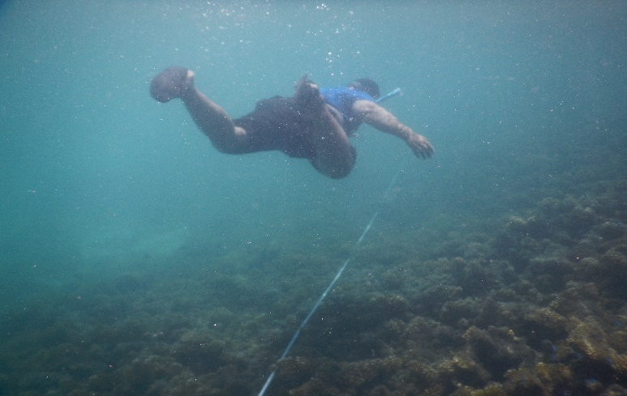
A belt transect is typically used to count fish or other organisms on the reef or seabed that can be easily seen while snorkeling. Practical on land first and then proceed to marine areas.
Figure 11: Ridge to Reef diver conducting belt transect, Funafuti. Photo by Tauati Pai (25/10/2018).

Below are the steps for conducting a belt transect method;
  - Lay a 100-meter measuring tape on desired area, making sure it is not snagged on any rocks or coral. Lay the tape with reference to a compass reading and record bearing and position of the starting, middle and ending point of the measuring tape.
  - Wait 15 minutes to allow fish and other organisms to resume normal behavior after being disturbed by divers placing the tape.
  - Begin swimming slowly along the transect line. At every five meters (5,10,15, 20 ,etc.), stop and count the fish for 3 minutes within a 5-meter corridor (2.5 meters on either side of the tape). You can use a full arm’s length (slightly shorter than 2.4 meter) as a guide for the distance. Record the number on an underwater slate. Do not count fish outside the 2.5 meter sampling area on each side.
  - If diving in pairs, one dive records fish on one side of the line (2.5 meters or arm’s length) and another on the other side. Alternatively, Diver 1 can record the first 20-meter segment and Diver 2 can do the second 20-meter segment and so on. Care is needed to properly label slates and to avoid double counting.
  - In addition to counting the number of fish, sizes can also be estimated. Write all information down on your underwater slate.

Line Transect with Quadrat
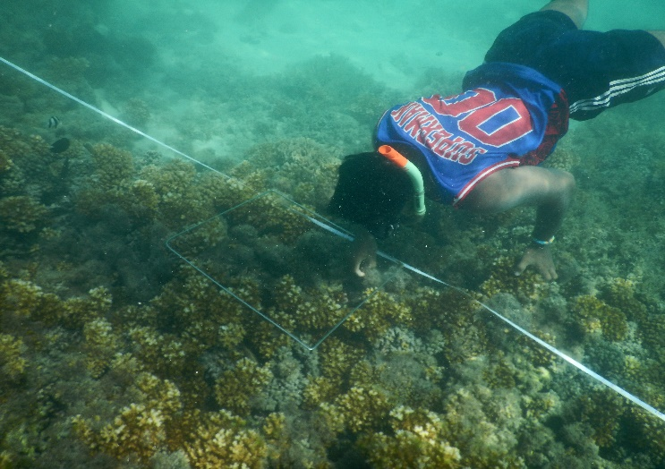
This method utilizes a 100-meter line together with a 1-meter quadrat (one square meter of wood, PVC pipe or stainless steel divided by string into 100 equal smaller squares). This method is used to determine substrate types and amount of coverage, as well as the population of sessile marine species. For example, use this method to determine the presence or absence of hard and soft coral (alive or dead), shellfish and seagrass, and the respective percent coverage of each. Practice on land first.
Figure 12: Diver conducting line transect with quadrat, Funafuti. Photo by Tauati Pai
Figure 12: Ridge to Reef diver conducting line transect with quadrat, Funafuti. Photo by Tauati Pai (26/10/2017).

- Lay a 100-meter measuring tape carefully on the reef or seabed. Lay your transect line with reference to a compass reading and record reading and geographical location.
- Lay the quadrat every 10 meters starting from 0 meters.
- For marine resource (species) monitoring –
  - Count the number of target species within the quadrat. Do not count outside the quadrat.
  - Use a separate meter tape or ruler for measuring individual sizes.

For reef ecosystem (habitat) monitoring –
- Estimate the percentage of live coral, dead coral and sand/rubble coverage within the quadrat by counting the number smaller squares in which each type of cover is dominant. For example:

Live Coral = 32 squares = 32% coverage
Dead Coral = 30 squares = 30% coverage
Sand/rubble = 38 squares = 38% coverage

Creel Survey
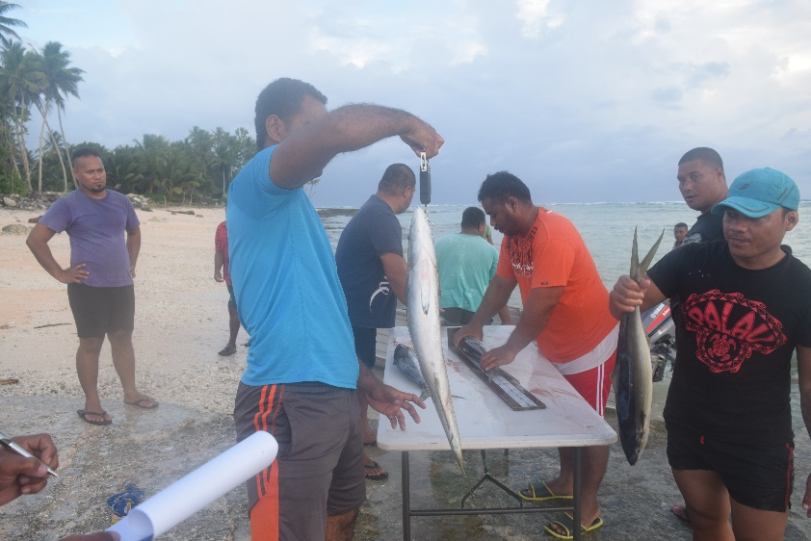
This is one of the most important fisheries techniques to monitor daily harvesting of finfishes (reef fish, deepwater fishes) within the territorial waters. Every fish must count, weigh and measure their length and recorded in a datasheet. Fisheries data collector and Ridge to Reef Island Officers has appointed to carry out this creel survey in all islands of Tuvalu.
Figure 13: Fisheries Officer conducting Creel Survey in Nui Island. Photo by Lale Petaia (18/10/2016)

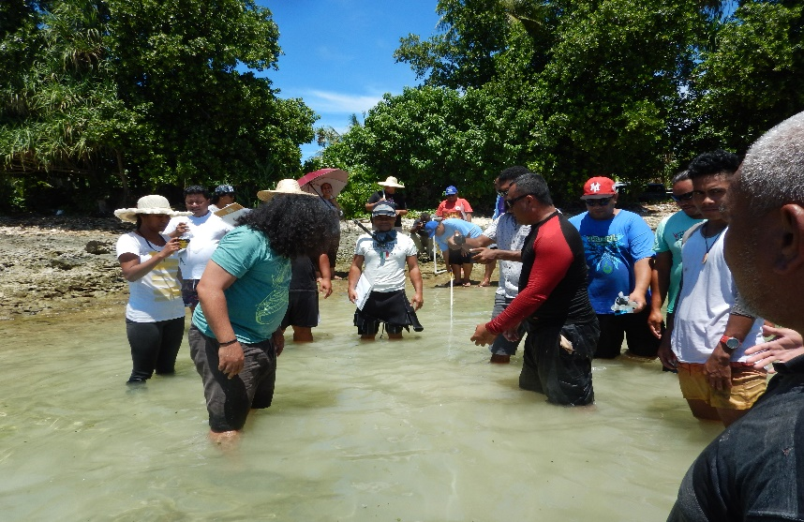
4.2.4 Practical Exercise
Figure 14: Ridge to Reef Team practicing transect method, Funafuti. Photo by Tauati Pai.(25/10/2017)

The workshop participants get in the water and practice the biological monitoring methods they have learned on land. The aim of this practical exercise to allow participants to build their skills and practice monitoring before performing and actual baseline monitoring survey to obtain data for analysis.

4.2.5 Conducting a Baseline Survey
A survey should be done as close to the start of the project as possible. This is the baseline survey. The data collected during the baseline survey will be kept as a record of the condition of the marine resources at the beginning of the project, and will be compared to data from future monitoring to see what is happening to the marine resources as a result of management actions. The same survey is done at regular intervals to learn how things are changing.

4.2.6 Data Analysis
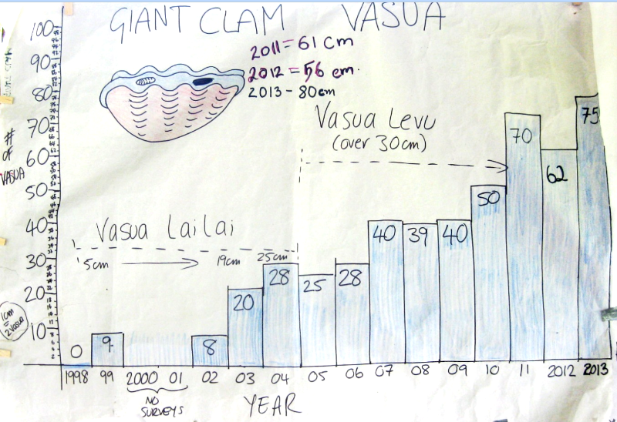
After doing the monitoring and collecting data, it is necessary to analyze and interpret it so that it will be useful to the community in making decisions about their management actions. In this exercise, raw data from monitoring are recorded, analyzed, presented and discussed. It necessary to sum up the data from all the transect or quadrat counts and put in a table, make sure to label the title, vertical and horizontal axis of the graph.
Table 5: Data Analysis of Waitabu MPA, Fiji. : (Sykes, 2016)

4.2.7 Develop Monitoring Plan
Now that you have your baseline data, you will need to do continued monitoring to collect data to compare against your baseline to see what changes are taking place in your LMMA as a result of your management actions. Participants discuss how they will perform the continued monitoring of their site and present data back to their community.
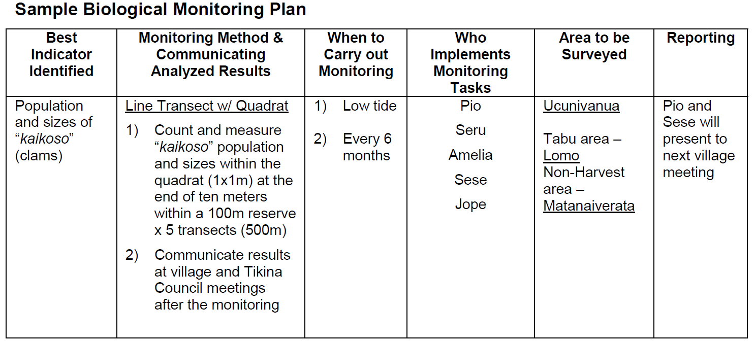
Through this discussion, the participants will list down all the logistics requirements and the timeframe for conducting this monitoring.
TTable 6: Above is an example of a biological monitoring plan from a Fiji LMMA site. (Govan, Aalbersberg and Tawake, 2008)

4.3 Socioeconomic Monitoring
Socioeconomic monitoring will help you assess the changes that occur in the social, cultural and economic well-being of your community as a result of your management actions. Socioeconomic monitoring is just as critical as biological monitoring in determining the success of your LMMA. The steps for socioeconomic monitoring are basically the same as for biological monitoring.

4.3.1 Methods Training
The socioeconomic methods mainly focus to direct observation and interviews using questionnaire. Given an overview of each method and discuss with the community which would be most appropriate for the indicators they have chosen to monitor.

Direct Observation
Direct Observation is a technique that involves recording observations of key factors or issues relevant to the project goals and objectives. This may involve observing and recording individuals, groups, processes, events, or relationships. For example, you may count the number of people attending a village meeting or you could observe the number of fish caught and sold daily to determine how much income is earned.

Interviews
An interview is a method to gather in-depth qualitative information. Questions are generally open-ended, meaning the respondent can answer the question he or she is asked in different ways. Interviews can take place individually or in different groups. For example, household survey, focus groups and key informants.

4.3.2 Develop Socio-economic Monitoring Plan
Develop a socioeconomic monitoring plan for each community using the following headers: Socioeconomic Factor, Indicator, Method, Monitoring schedule (how often, time of year, etc.), Monitoring team.

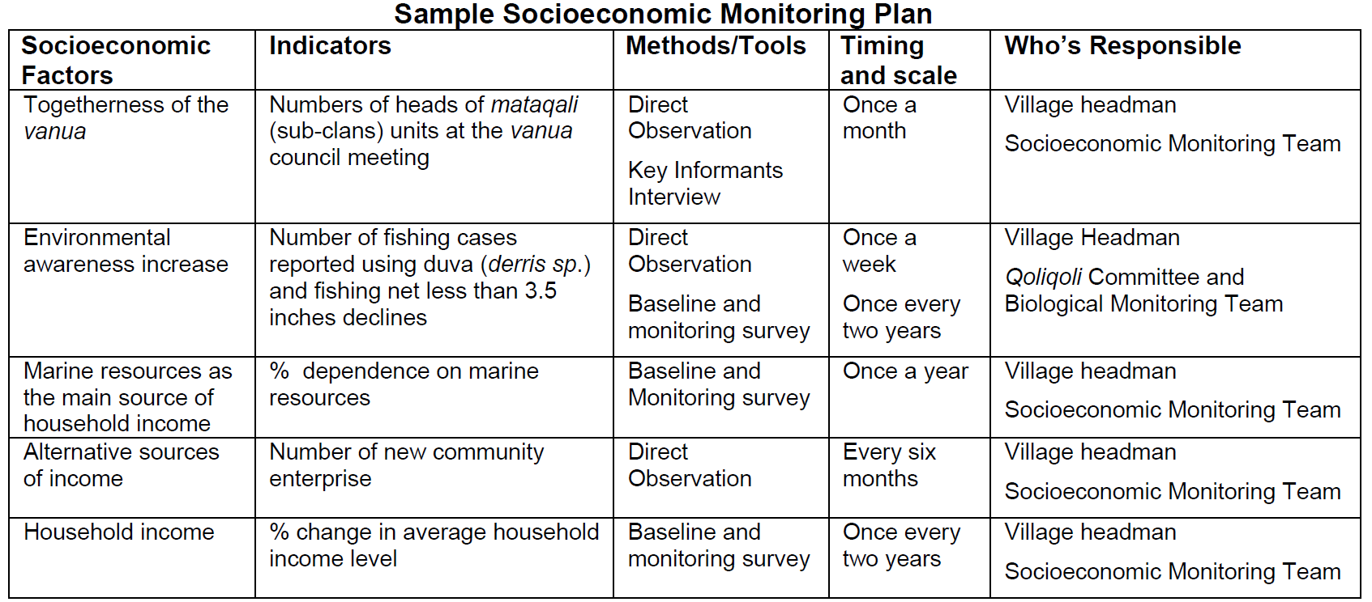
TTable 7: Above is an example of a socio-economic monitoring plan for the Vueti Navakavu Project in Fiji. (Govan, Aalbersberg and Tawake, 2008)

ONGOING COMMUNITY BASED ADAPTIVE MANAGEMENT

5.1 Review Action Plan and Monitoring Data

5.1.1 Community-Based Adaptive Management Meetings
A main focus of Community-Based Adaptive Management is to encourage communities to plan and make decisions based on facts. Therefore the review and analysis of the
Management plan and monitoring program are keys to project success. This approach will be new to many, so it is necessary to ensure these activities take place. It is important to conduct regular meetings to review the progress of the management plan and the analysis of monitoring data.

5.2 Maintaining No-Take Area Effectiveness
Almost all LMMA project teams decide to set up no-take zones in their fishing areas to help address overharvesting of their marine resources. While this can often assist in reviving species populations, there will always be some people who are inclined to take advantage of the bounty and fish in the no-take area. Therefore it is important to ensure that people know about the no-take area, where it is, what the rules are, and what the penalties are for breaking the rules. You may also need to consider patrolling the closed area to discourage poaching and to catch violators.
The following are some typical activities that you may want to consider for your no-take area. The exact nature of how these actions will be undertaken depends on the cultural,
geographical and legal factors surrounding your site and will need to be discussed among the community and project partners.

5.2.1 Declaration of Conservation area
Declaration can be traditional and/or legal. According to Tuvalu Conservation Area Act, the Minister is responsible for endorsing the declaration of any territorial area of Tuvalu as a Conservation Area upon receipt of a report from an island Kaupule (Island Council) and after due consultation with the Kaupule recommending the establishment of a Conservation Area. In most of the communities in Tuvalu, a conservation area is declared by the community elders (Faekaupule) and enforced by the island council (Kaupule). There may also be community, and national meetings at which the declaration can be announced. Another part of the declaration is typically a statement about the rules concerning the area and the penalties for violating them. These penalties may be traditional in that violators may face social repercussions or public shame.
In other societies, a more legalistic approach is needed whereby different violations have specific fines under a community legal system. Rules and penalties can be posted on signs in or near the fishing and no-take areas or printed on posters hung around in the community or handed out to each household.

5.2.2 Demarcation of Conservation Area Boundaries
Before declaring the conservation area of an island, Communities need to agree on the total area of LMMAs and MPA to be marked as protected area. Tuvalu Fisheries Department and project partners provide technical assistance to island communities in demarcating boundaries for conservation area and also facilitating communities on various methods that can be used to mark conservation boundaries.

Map of the Conservation Area of Vaitupu Island
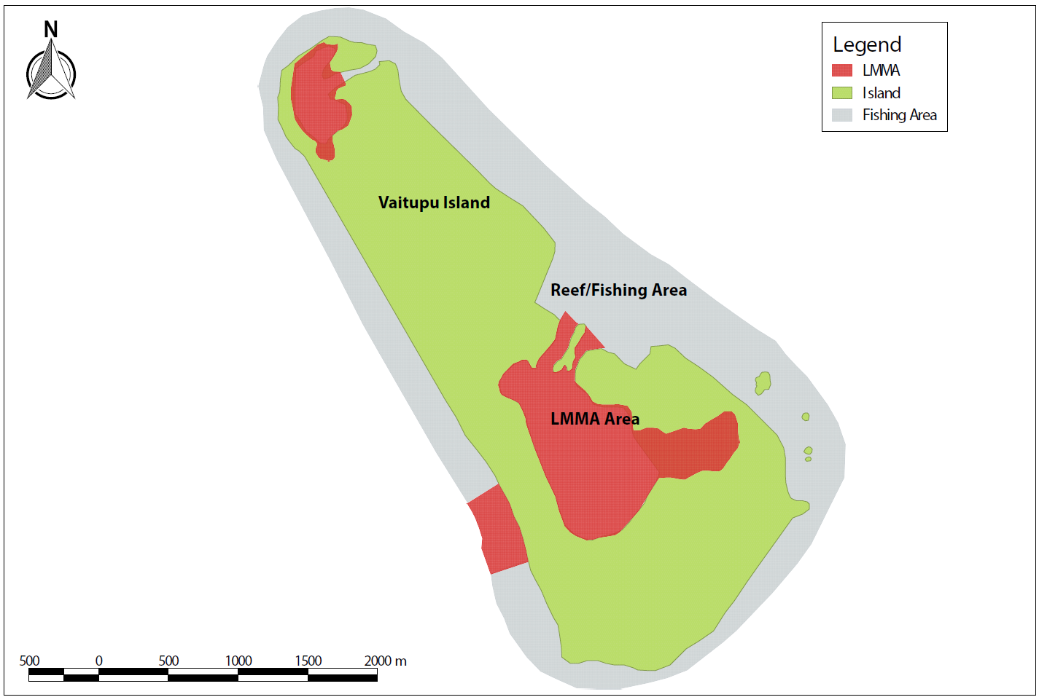
Figure 15: Conservation Area Map provided by the Ridge to Reef Project and Tuvalu Fisheries Department.

5.2.3 Patrolling
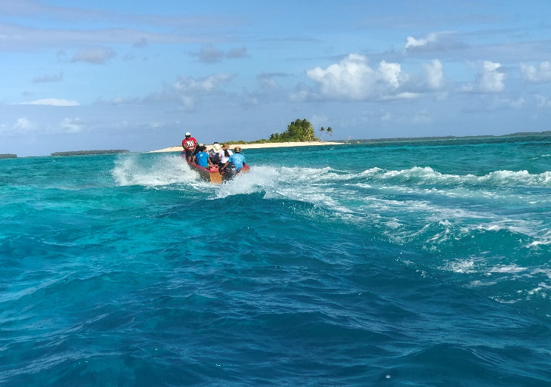
Once the no-take area has been declared, the issue of patrolling arises. This is generally a responsibility of the community to determine what is necessary. In Tuvalu, patrolling is done by conservation officer or qualify officer who authorized by the Kaupule (Island council).This process may be facilitated by the project partner.

Patrolling is obviously easier if the no-take area is visible from the village area rather than far away from it. If it is far, speed boats will be needed and/or assistance by national authorities. Each community will have to determine what is best for their site.
Figure 16: Funafuti Conservation Officer and Ridge to Reef Team patrol Funafuti Conservation Area. Photo by Lamese Saamu.

5.2.4 Sharing Lessons Learned
It is always beneficial to provide people with the chance to reflect on what they have learned and discuss this with other practitioners. One of the most powerful sources of learning is sharing experiences and ideas among practitioners. This can be done by several means. Project partners and communities can meet regularly to discuss activities and share anecdotes from their sites. Different sites can hold cross-site visits, where members from one project visit another site to exchange knowledge, skills and stories (this can be done within country or even with other nations). This is a great way to help villages new to the LMMA process get up and running and improve their efforts, as well as learn about different perspectives and techniques. Finally, formal meeting with projects from many countries in the region to formally discuss results and share lessons can help to energize and enlighten practitioners and renew their efforts.

5.2.5 Upscaling LMMA Work
As projects proceed and expand there are often issues identified that are beyond the community’s ability to solve and which need a regional or national approach. Rehabilitation of coral reefs and important valuable marine species for livelihood that necessary need scientific assessment and technical methodology in conducting a rehabilitation program. Climate change and disaster risks devastated healthy growth of marine species and ecosystems. It recommended that communities in collaboration with national and regional partners to develop a mechanisms that enable community to build their capacity on LMMA work and conservation monitoring and management.

References

Bunce, Leah and Pomeroy, Bob. (2003). Socioeconomic Monitoring Guidelines for
Coastal Managers in Southeast Asia (SocMon SEA). World Commission on Protected
Areas and Australian Institute of Marine Science. Available for download at:
http://ipo.nos.noaa.gov/socioeconomic/pdfs/SocMonSEA.pdf

Bunce, Leah, P. Townsley, R. Pomeroy, R. Pollnac. (2000). Socioeconomic Manual for
Coral Reef Management. Australian Institute of Marine Science. Available for download at:
http://ipo.nos.noaa.gov/socioeconomic/pdfs/GCRMN_Manual.pdf

Desurmont, A. (2017). Creel and market surveys manual. [online] Spc.int. Available at: http://www.spc.int/coastfish/en/publications/478.html [Accessed 9 Nov. 2017].

Govan, H., Aalbersberg, W. and Tawake, A. (2008). Locally-Managed Marine Areas: A guide to supporting Community-Based Adaptive Management. Suva: Locally-Managed Marine Area Network, pp.1-64.

Info, C., Team, O., Assessments, M., Projects, E., Awareness, M., Areas, M., Management, M., Services, T., Interpretation, M., Weeks, G., Support, S., Groups, U., Interns, I., Government, F., Universities, I., Organisations, N., Monitoring, R., Info, U., (COTS), C., Fiji, F., equipment, M., Management, M., Books, R., Book, W. and us, C. (2017). Marine Protected Areas - Marine Ecology Consulting. [online] Marine Ecology Consulting. Available at: https://marineecologyfiji.com/services/marine-protected-areas/ [Accessed 9 Nov. 2017].

MOEAKIGA O MALEFATUGA II. (2016). Suva, pp.1-52.

Sykes, H. (2016). Waitabu Village, Fiji Islands 18 years of marine management and and community monitoring.

Tawake, A., Meo, S., Cakacaka, A., and Aalbersberg, B. (2003). Community Based
Biological Monitoring Training Guide. Application: FLMMA Project Sites
at Tagaqe Village, Tikina Korolevu-Iwai, Nadroga. Institute of Applied Science, Suva, Fiji.
Available on the LMMA website www.lmmanetwork.org under Resources.

Worah, S., Svedsen., D.S., Ongegleo, C. (1999). Integrated Conservation and
Development: A Trainers Manual. ICDP Training Programme, Asian Institute of
Technology and WWF -International, Khlong Luang, Thailand. 258 pages.

