Chuuk State MPA Compliance & Enforcement Training
Chuuk Ridge to Reef Program
December 4-15, 2017

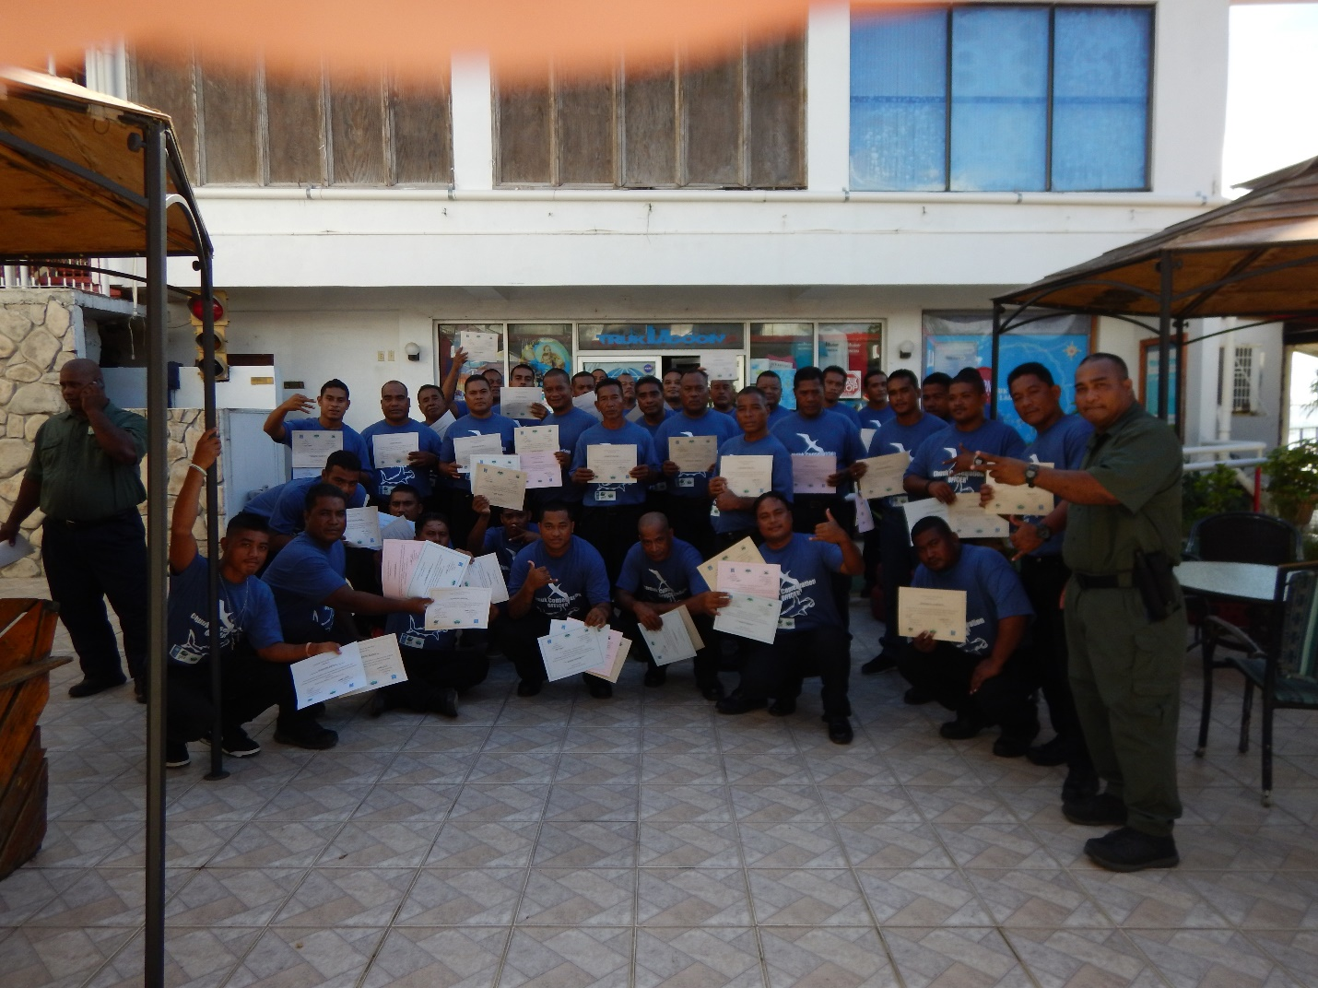

Background & Discussion:

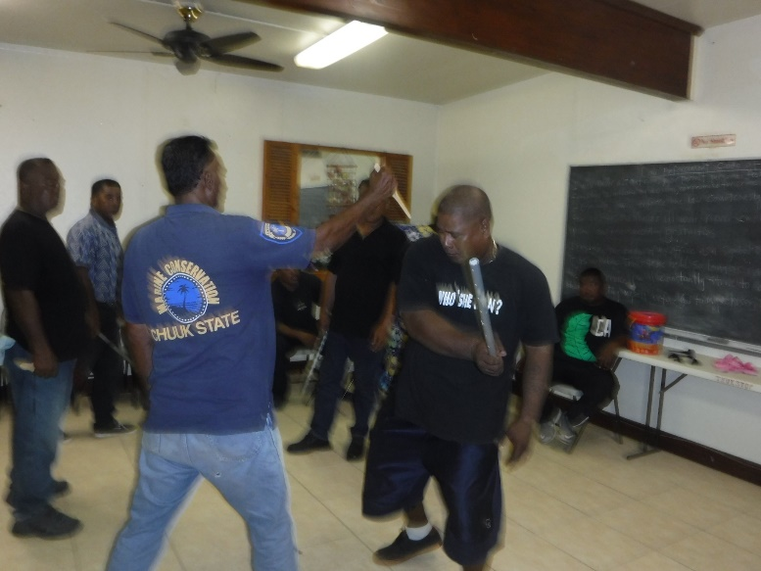
Marine protected areas have slowly grown in number in Chuuk over the years. With the addition of new sites, comes additional challenges. Resources become stretched thin and the need for capacitating others and building partnerships with key stakeholders becomes increasingly relevant. This becomes even more critical when dealing with issues of maritime law enforcement, where carrying out every-day duties can be dangerous work.

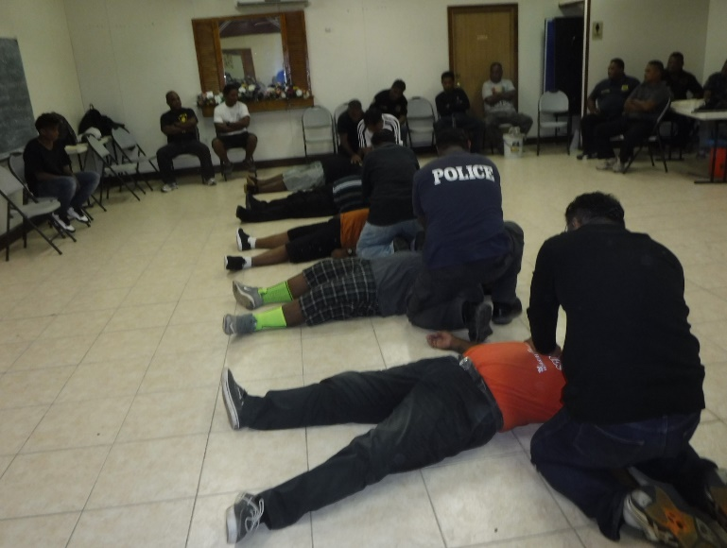
The MPA Compliance & Enforcement Training conducted December 4th – 15th, 2017 was planned in the effort to address these challenges, and provide proper training to State and Municipal Police Officers, as well as Community Conservation Officers representing Marine Protected Areas throughout the Chuuk Lagoon. The training covered a wide range of topics necessary for maritime enforcement and surveillance, from proper officer code of conduct, vessel boarding and proper handcuffing techniques, use of logbooks and case reporting, to first aid and self-defense.

The training was facilitated by Marine Conservation Officer Chimres Teresio, an employee of the Department of Marine Resources for 10+ years and recent graduate of the MPA Compliance & Enforcement Training held in Guam. Approximately 40 participants representing the Chuuk State Department of Public Safety, Municipal Police Officers from the islands of Parem, Fefan, Uman and Weno, and Community Conservation Officers from Tol, Parem, Uman, Ununo, UFO, Fanapanges and Weno attended the training. In total, 5 Marine Protected Areas were represented from throughout the Chuuk Lagoon, with an additional training planned separately in the future for the Oneisomw Municipal Police Officers and Community Conservation Officers.

MPA’s Represented | Municipality | Region
Mwanukun | Uman | Northern Namoneas
Tiun | Parem | Southern Namoneas
Sopwonoch | Weno | Northen Namoneas
Unnuno | Fefan | Southern Namoneas
Wichukuno | Tol | Faichuuk

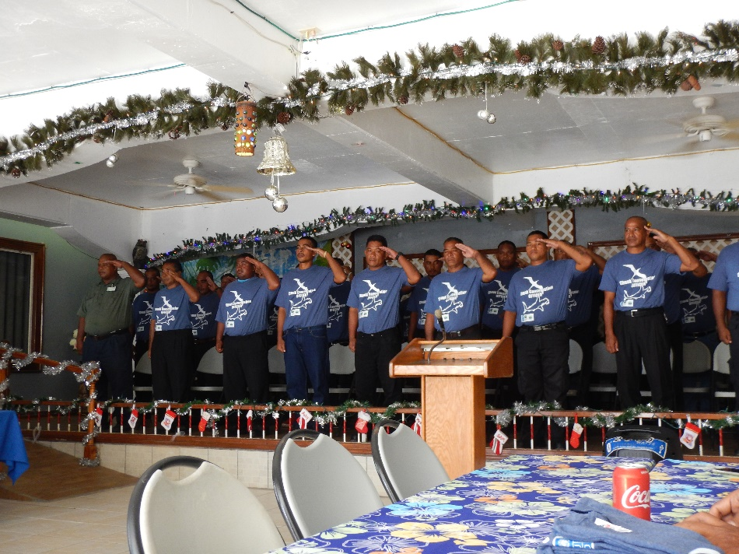
An important aspect of the recently concluded Enforcement training, was having participants from different levels of enforcement, whether it be at the State, Municipal or community level, together attending the workshop. Collaboration and familiarity with partners at all these levels are a critical part of proper surveillance and enforcement, and can often mean the difference between a successful operation or not. This is especially essential for us in Chuuk when considering the complex reef tenureship traditions we practice, with layers of ownership and jurisdiction from the State Level on down to Municipal, Community and in some cases the family or individual level. It was therefore important to bring together these different layers into one training so that they learn the same basic skills and can transfer that knowledge into the field. In addition, by getting to know one another, these officers are better able to collaborate with the enforcement of maritime regulations within their own jurisdictions, therefore pulling together resources that in the past primarily acted independently of one another.

Potential Next Steps:

- Continue to build upon completed MPA Compliance & Enforcement Training with smaller, less intensive refresher trainings, for participants of recently concluded training in December 2017.
- Take MPA Compliance & Enforcement Training to neighboring islands to further train Municipal and Community Conservation Officers, using participants from December training as co-facilitators.
- Formalize stakeholder collaboration and partnerships between State, Municipal and Community Enforcement Officers.
- Provide opportunities to Enforcement Officers to further their training abroad.

