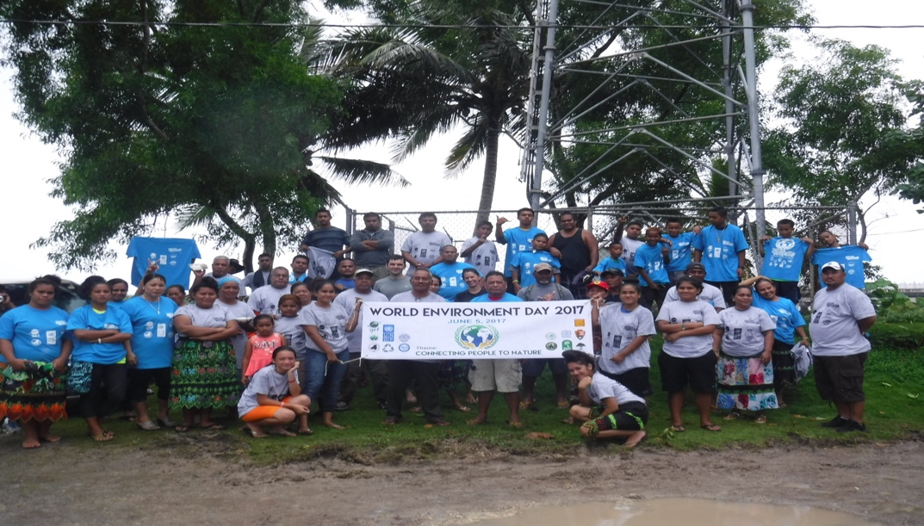
The Kosrae Island Resource Management Authority (KIRMA), in partnership with the FSM Ridge to Reef (R2R) Project and other key stakeholders coordinated the observance and activities of this year’s World Environment Day on June 5th, 2017. This year’s theme was, “connecting people to nature”. The World Environment Day is an annual event held on June 5 to raise global awareness on the importance of the environment and natural resources.
In Kosrae, the observance of this year’s Environment Day was held at the Tafunsak Marine Protected Area (MPA), where numerous government agencies, the Tafunsak Municipal Government, NGOs, community members and volunteers gathered to conduct multiple land and underwater clean-up activities. More than 200 people showed up to participate and volunteer their time to clean within, around and below the marine water of the Tafunsak MPA. Debris being collected included discarded metals, tires, fishing nets, soda cans, plastic bags, ceramic materials and clothing were collected by both members scouring land surface areas, divers and snorkelers.
This year’s World Environment Day was sponsored by the R2R Project, KIRMA, Division of Fisheries & Marine Resources through the Department of Resources & Economic Affairs, Division of Sanitation through the Department of Health Services, the Tafunsak Municipal Government, Tafunsak Women Association, Tafunsak Resource Management Committee (RMC), Kosrae Conservation & Safety Organization (KCSO), Pacific Resources for Education and Learning (PREL), the International Organization for Migration (IOM),the US National Park Service (NPS), Kosrae Nautilus Resort and the Green Banana Company. Support by all sponsors was provided through man hours and resources such as collection trucks, fuel, t-shirts, trash and mesh bags, diving tanks/gears, gloves, catering, boats, dump and pick up trucks, loader and cranes, etc.
The R2R Project, on behalf of KIRMA and other key partners, would like to thank all of those who volunteered their time to make the Environment Day event a success.

