Press Release
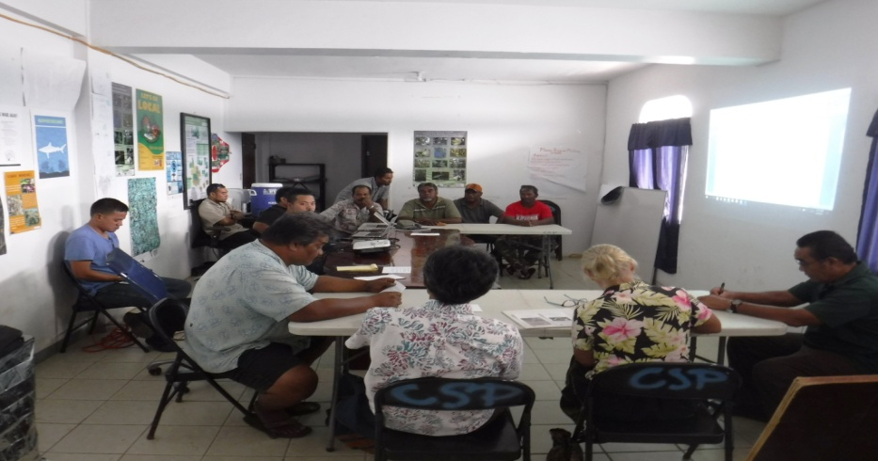
KOLONIA, Pohnpei – On February 16, 2017, state level implementing partners for the ongoing GEF5 Ridge to Reef (R2R) Project convened at the Conservation Society of Pohnpei’s conference room.The meeting, facilitated by the Pohnpei State Coordinator, Mr. Jorg Anson, was conducted to fully inform stakeholders on persisting issues that need to be addressed in order to promote a widespread uptake of DLPs. Discussions touched on both biological and socioeconomic factors of DLPs and ways to effectively improve water quality in highly contaminated rivers and streams in Pohnpei.
The meeting also revived the Pohnpei Piggery Advisory Council to assume a leadership role for the expansion of Dry Litter Piggery (DLPs) efforts in Pohnpei. With the positive outcome of a DLP project that was piloted in the village of Awak in U Municipality in recent years and its impactful awareness efforts, the interest among farmers to adopt this new method of piggery has skyrocketed in other communities throughout Pohnpei.
Approximately $150k is available from Compact Sector Funds and the Ridge to Reef Project to be used for DLP construction with majority coming from the former.In addition to the construction of new DLPs, the program will consist of the five following components:
- Conduct lesson learning process to determine and understand the social and economic barriers preventing widespread uptake of the technology to date, and identify novel approaches or adaptation of current approaches that will overcome these barriers.
- Build awareness among farmers and communities around (a) negative impacts of regular piggeries on the environment and human health and (b) the economic/environmental/health benefits of dry litter piggeries, and the opportunities available to convert existing piggeries to dry litter piggeries.
- Provide technical extension services to farmers and training opportunities to assist with the conversion to and management of dry litter pigpens
- Bridge the capital barrier for making the conversion by working with the Awak piggery project and the Piggery Waste Management Revolving Fund to up-scale the revolving fund to operate across the whole of the FSM.
- Scientifically monitor (a) farmers’ experiences (success/failures), (b) environmental impacts of the program, specifically water quality and agricultural benefits such as value of compost to farmers or changes in agriculture outputs as a result of compost addition.
The outcome of the meeting was a proposed selection criterion that will be used to select new farmers and sites. The group has agreed to finalize the proposed selection criteria and submit to the Pohnpei State Government for official endorsement. The Ridge to Reef Project team looks forward to begin building new DLPs in Pohnpei throughout the year.
The State Coordinator wishes to thank the Conservation Society of Pohnpei for providing its conference room as an in-kind support to the project as well as Pahp Trakie’s for their catering services.
More in the loop in our next R2R update!
For more details on the R2R in FSM project, please contact:

National Project Implementation Unit: Project Manager, Rosalinda Yatilman
ryatilman@gmail.com
Tel:+691 320-8815
Fax: +691 320-8936

Chuuk State R2R Coordinator: Kriskitina Kanemoto, krizk66@gmail.com

Kosrae State R2R Coordinator: Blair Charley, charleyblair@gmail.com

Pohnpei State R2R Coordinator: Jorg Anson, jorgyanson@gmail.com

Yap State R2R Coordinator: Debra Laan, debra.laan@gmail.com

